

# Bangladesh University of Business and Technology

### Project Report

**Project Name: Calendar – with Structure Programming Language (c)**



**Bangladesh University of Business and Technology**

**Project Report**

**Project Name: Calendar – with Structured Programming language (c)**

**Submitteed To**

**Md. Saifur Rahman**

**Chairman**

**Department of Computer Science & Engineering,BUBT**

**Submitted By**

|  |  |
| --- | --- |
| **Name** | **ID No** |
| **Sadeka Jafrin** | **18192103069** |
| **Syeda Saloya Rahman** | **18192103066** |
| **Ishmoth Ura Nuri** | **18192103237** |

**Abstract:**

The Project report is completed based on the development methods of Calendar. This report tries to identify the overall development methods of Calendar. The first chapter of the project report describe the introduction, the problem statement, the motivation and the objective of the project , the object of the project the Calendar’s overview. The two chapter of the Project report, it provides an insight about the overall activities of Calendar .Finally, in the three chapter of this report sample code of the project , screen short of the project , limitation & future work and reference are provided.

Acknowledgement:

We thanks Mr.Saifur Rahman Sir (Chairman) who have been the great inspiration and who have provided sufficient background knowledge and understanding of this project.

We offer our sincere thenks to our respected faculty members Mr.Kazi Kahid (Asst. Professor), Mr.Fazle Rabbi (Asst. Professor) who are teach us structure programming language(c).

We feel privileged to extend our deep sense of gratitude to our parents for their support and encouragement.

Last but not least we would like to thank our friends Syeda Saloya Rahman, Ishmoth Ura Nuri, Tanvir and all classmates for their support in completing the project.

**Index**

|  |  |  |  |
| --- | --- | --- | --- |
| 1.1 | **Introduction** |  | Page no |

**Chapter #1**

**Introduction**

**1.1: Introduction:** Theoretical knowledge is not enough for a student. There is a difference betweentheoretical knowledge and practical development experiences. The most important purpose of a software development 1 program is to know about rules, regulation , and environment that an organization usually has. A software development 1 program will also help students to gather some experiences which help to achieve some arts to participate actively in the corporate world or in a real job field.

This report is being prepared as a requirement for the fulfilment of the software development 1 program at BUBT. The topic of this training and development program of Bangladesh University of Business and Technology(BUBT).

In our everyday life, we all have to go with the time and date. Without knowing the date we can’t walk a single. To maintain the timing sense, we must need a space of all dates(such as, normal dates, important dates, special dates etc.). So, calendar is that space where we can get all types of dates easily in sequence.

**1.2: Problem Statement:**

We want to develop an application to make a calendar. We develop this Calendar using Structured programming language. Here, all dates , such as normal days, important days, special days will be shown.

1.3

**1.3 Motivation:**

Our respected course instructor Chairman **Md. Saifur Rahman**, Department of CSE, Bangladesh University of Business & Technology(BUBT). He first motivate us to create any application base project. Then we discuss with our team member and decide to develop a Calendar. Then our all team member learns about this project.

**1.4 Objective of the Project:**

* Learn structure purpose
* Learn struct part of C language

Chapter #2

**Propose Model**

**2.1 Supporting Literature:**

1. Structure data file
2. Pre define function
3. Void function
4. Constructor
5. For loop
6. Nested loop
7. Structure Calender
8. Main function
9. If-else if-else statement

**2.2 Algorithm of Propose Model:**

**Algorithm of Calender**

**Step 1:** Start

Step 2: create a simple array statement to count days in months

Step 3: Create void functions of year, leapyear, daycode

Step 4: Create parameters of daycode to count the days in a month ,

Create parameters to check whether it is leap year or not.

Step 5: Use for loop statement to continue the months in a year

Step 6: Use nested loop statement to count the days in months.

Step 7: use if-else if-else statement to find out the special dates, important days in a year

Step 8:End

**2.3 Flowchart of Proposal Model**

**Flowchart of Calender**

Input

Day

Show Calender

No Data

If (1951<=Date<=2050)

Input

(Date: Year)

If (Day of Month=16,26,21…etc)

**YSE NO**

No DATA

Show Special

Day

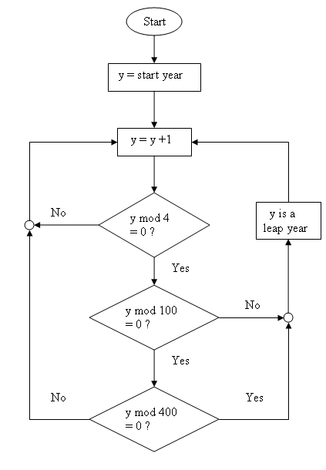

**Chapter 3**

**Conclusion**

**3.1 Simple code of the project**

**Sample#1**

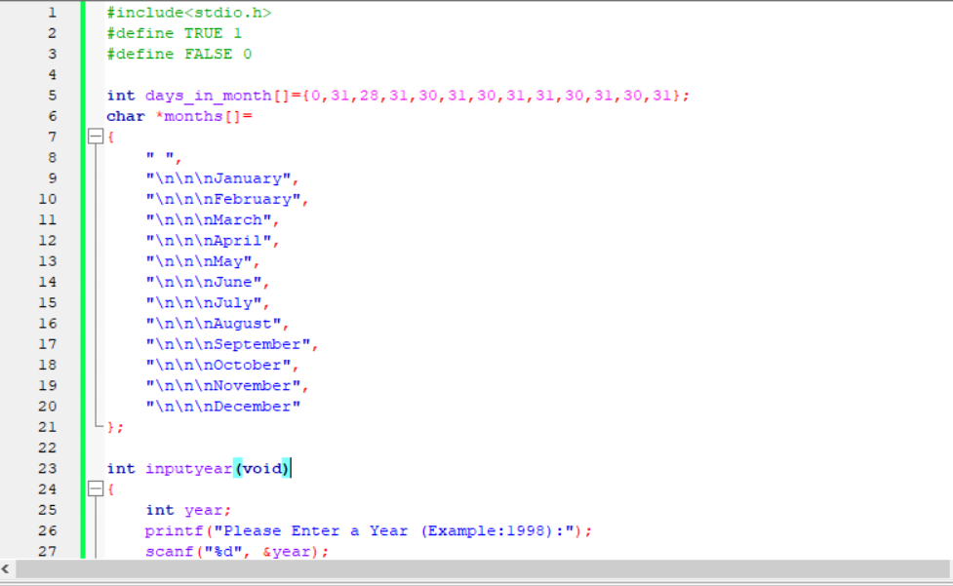

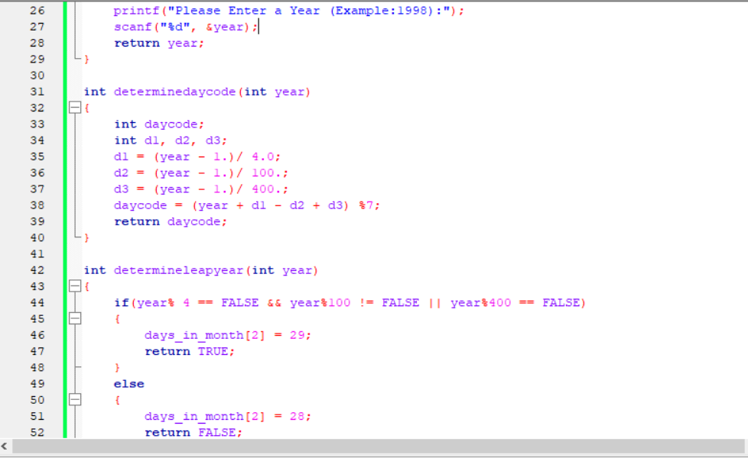

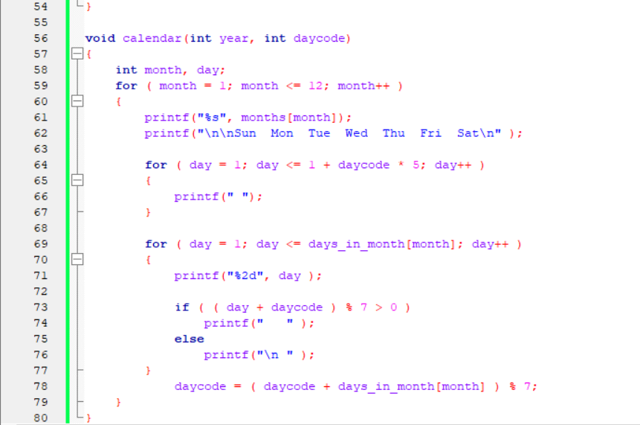

**Sample #2**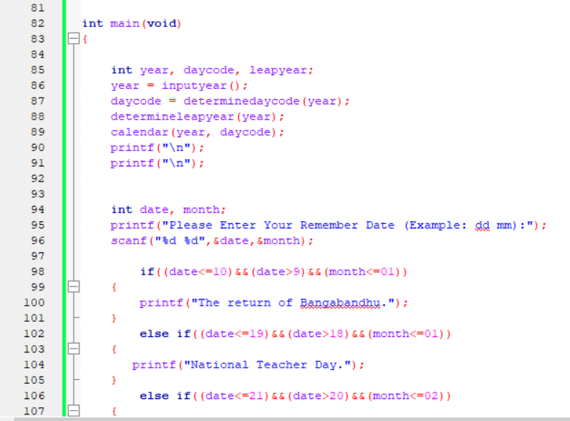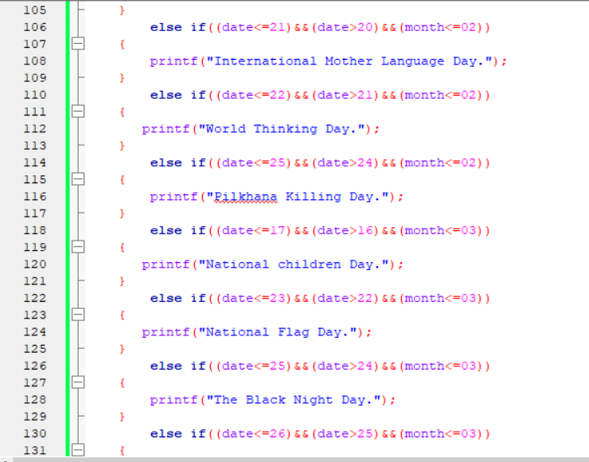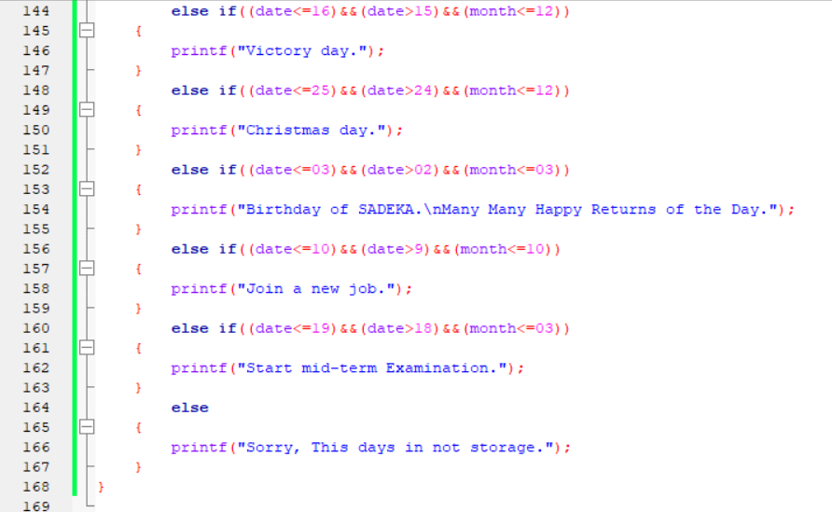

**#.2 Screenshot of the Project**

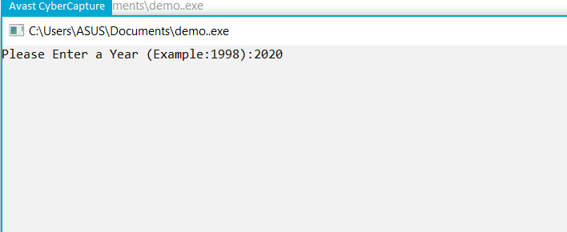

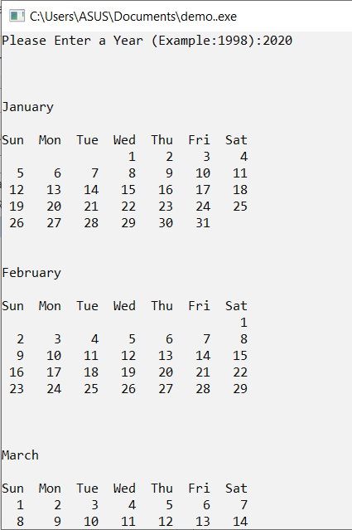

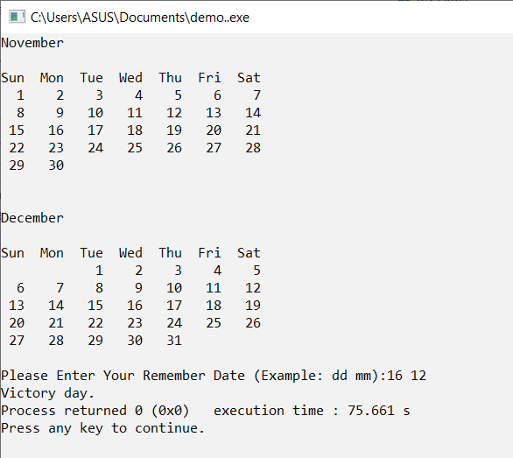

**3.3 Limitation and Future work :**

**Limitations:**

* **We can’t add any reminder.**
* **We can only see calendar between 1951 to 2050.**
* **We can only see some limited day event.**

**3.4 Future work**

* **We will add reminder.**
* **We will add more special day.**
* **We will add some graphics.**